Prompt:

causal_model = chat([

SystemMessage(content='''Your job is to respond to counterfactual questions regarding the causal model defined below. The causal model is based on Judea Pearl's definition and many of the questions use Pearl's "do-calculus" to represent an intervention. Assume the causal model is a complete representation of the causal relationships in the scenario.

Description:

Two round NBA playoffs, with the LA Lakers vs the Denver Nuggets in the Western Semifinals and the Boston Celtics vs the Miami Heat in the Eastern Semifinals.

Variables:

Injured (I)

Home Court Advantage in the Semifinals (HCS)

Home Court Advantage in the Finals (HCF)

Victory (V): Whether a team wins a game.

Semifinal Champion (SC)

Finals Champion (FC)

Skill Advantage (SA)

Finals Most Valuable Player (MVP)

Hall of Fame (HF)

Causal Interactions:

Injured (I) → Victory (V): A team getting injured (Team(Injury=1)) decreases that team’s chance of victory.

Injured (I) → Skill (SA): A team getting injured (Team(Injured=1)) reduces that team’s skill advantage.

Home Court Advantage (HC) → Skill Advantage (SA): A team having home court advantage (Team(HC=1)) increases that team’s skill advantage, since they play better at home.

Semifinal Champion (SC) → Finals Champion (FC): A team becoming semifinal champion Team(HC=1) increases that team’s chance of becoming finals champion.

Skill Advantage (SA) → Victory (V): A team possessing a skill advantage over their opponent (Team(SA=1)) positively influences their chance of victory.

Finals Champion (FC) → Most Valuable Player (MVP): A team becoming finals champion (Team(FC=1)) increases the chance that one of their player’s will win most value player Player(MVP=1).

Victory (V) → Semifinal Champion (SC): A team winning a game in the playoffs (Team(V=1)) increases their chance of becoming semi-finals champion.

Victory (V) → Finals Champion (V): A team winning a game in the playoffs (Team(V=1) increases their chance of becoming finals champion.

Finals Most Valuable Player (MVP) → Hall of Fame (HF): A player winning the Finals MVP (Player(MVP=1)) increases the player’s chance of becoming a hall of fame player.

'''),

HumanMessage(content='''Create a graph representing the causal model.''')

])

Response:

Here is the graph representing the causal model you described:

[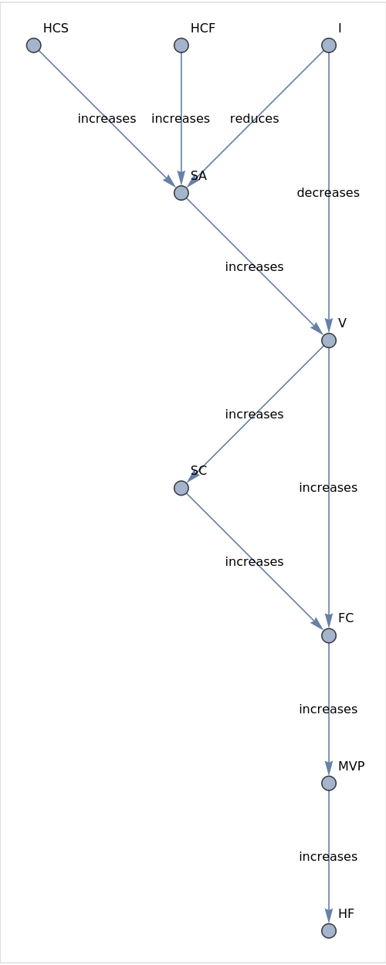](https://www.wolframcloud.com/obj/e1adb73c-3756-4c13-b9be-a1fe93bc2fca)

1. Causal Inference Statement
   1. natural language
      1. HumanMessage(content='''Your friend says that if Lebron James wins Finals MVP, then the LA Lakers are likely to win the Western Conference Semifinals. Is this statement accurate according to the causal model?''')
      2. This statement is not accurate according to the causal model. The Finals MVP (MVP) is determined after the Finals Champion (FC) is decided, which occurs after the Semifinal Champion (SC) is determined. The Western Conference Semifinals is a stage before the Finals, so the outcome of the Finals MVP cannot have a causal influence on the outcome of the Western Conference Semifinals.
   2. do-calculus
      1. HumanMessage(content='''Lebron(MVP=1) → LA(SC=1). Is this statement accurate according to the causal model?''')
      2. No, this statement is not accurate according to the causal model. The causal model does not have a direct causal link between a specific player winning the MVP and their team becoming the Semifinal Champion. The model only shows a link between Finals Champion (FC) and Most Valuable Player (MVP).
   3. Which one is better? Natural Language!
      1. Both responses correctly identified that the statement is inaccurate, but the natural language prompt produced a response that better identified the flaw in the statement’s causal reasoning.
2. A Slightly Flawed Counterfactual Statement
   1. Natural language
      1. HumanMessage(content='''Denver was not injured and won the semifinals championship over LA, so injuring Denver would have caused LA to win the semifinals championship instead. Is this counterfactual statement accurate according to the causal model?''')
      2. According to the causal model, injuring Denver (Team(Injured=1)) would decrease Denver's chance of victory (Injured(I) → Victory(V)) and reduce their skill advantage (Injured(I) → Skill(SA)). However, it does not guarantee that LA would win the semifinals championship instead. The counterfactual statement is not accurate, as it overstates the certainty of the outcome. A more accurate counterfactual statement would be: "Injuring Denver might have increased LA's chances of winning the semifinals championship."
   2. Do-calculus
      1. HumanMessage(content='''Observation: Denver(Injured=0), Denver(SC=1). Intervention: Do(Denver(Injured=1)). Counterfactual: LA(Victory=1). Is this counterfactual statement accurate according to the causal model?''')
      2. Yes, this counterfactual statement is accurate according to the causal model. Observation: Denver is not injured (Injured=0) and is the Semifinal Champion (SC=1). Intervention: If Denver were to be injured (Do(Denver(Injured=1)). According to the causal model, an injury (Injured=1) would decrease Denver's skill advantage (SA) and their chance of victory (V). Since LA Lakers are Denver's opponents in the Western Semifinals, if Denver's chance of victory decreases due to the injury, it would increase the LA Lakers' chance of victory. Therefore, the intervention leads to LA(Victory=1).
   3. Which one is better? Natural language!
      1. The natural language response correctly identifies the flaw in the statement that the influence of injury on victory is relative, not absolute.
3. A Clearly Flawed Counterfactual Statement
   1. Natural language
      1. HumanMessage(content='''Given that the Miami Heat won the semifinals championship, the Heat would have not been injured if they'd had home court advantage. Is this counterfactual statement accurate according to the causal model?''')
      2. The counterfactual statement is not accurate according to the causal model. The causal model states that having home court advantage (HCS) increases a team's skill advantage (SA), but it does not directly influence whether a team gets injured (I). Therefore, we cannot conclude that the Miami Heat would not have been injured if they had home court advantage.
   2. Do calculus
      1. HumanMessage(content='''Observation: Heat(SC=1). Intervention: Do(Heat(HCS=1)). Counterfactual: Heat(Injured=0). Is this counterfactual statement accurate according to the causal model?''')
      2. No, this counterfactual statement is not accurate according to the causal model. The intervention Do(Heat(HCS=1)) refers to giving the Miami Heat home court advantage in the semifinals. However, the intervention does not have a direct causal effect on the Heat's injury status. The causal model does not show a direct link between Home Court Advantage in the Semifinals (HCS) and Injured (I).
   3. Which one is better? Undecided
      1. Both responses correctly identify the statement’s inaccurate leap in causal reasoning
4. Another Slightly Flawed Statement
   1. Natural language
      1. HumanMessage(content='''Given that the Heat became semifinals champions without semifinals home court advantage but did not become finals champions, the heat would have become finals champions had they had semifinals home court advantage. Is this counterfactual statement accurate according to the causal model?'''),
      2. According to the causal model, having home court advantage in the semifinals (HCS) increases a team's skill advantage (SA), which in turn positively influences their chance of victory (V) over their current opponent. However, the counterfactual statement claims that if the Heat had semifinals home court advantage, they would have become finals champions. While having home court advantage in the semifinals might have increased the Heat's skill advantage and chances of victory in the semifinals, it does not guarantee that they would have become finals champions. Other factors, such as injuries, skill advantage, and home court advantage in the finals, could also influence the outcome of the finals. Therefore, the counterfactual statement is not accurate according to the causal model, as it does not account for all the factors that could influence the outcome of the finals.
   2. Do-calculus
      1. HumanMessage(content='''Observation: Heat(HCS=0), Heat(SC=1), Heat(FC=0). Intervention: do(Heat(HCS=1)). Counterfactual: Heat(FC=1). Is this counterfactual statement accurate according to the causal model?'''),
      2. Yes, this counterfactual statement is accurate according to the causal model. The observation states that the Miami Heat did not have home court advantage in the Semifinals (Heat(HCS=0)), but they still became the Semifinal Champion (Heat(SC=1)). However, they did not become the Finals Champion (Heat(FC=0)). The intervention is to change the home court advantage in the Semifinals for the Heat (do(Heat(HCS=1))). According to the causal model, having home court advantage increases a team's skill advantage (Home Court Advantage (HC, HCS, HCF) → Skill Advantage (SA)), which in turn positively influences their chance of victory (Skill Advantage (SA) → Victory (V)). The counterfactual statement is that if the Heat had home court advantage in the Semifinals (Heat(HCS=1)), they would have become the Finals Champion (Heat(FC=1)). Given the causal model, this counterfactual statement is plausible, as having home court advantage could have increased their skill advantage and chances of winning games, potentially leading to them becoming the Finals Champion.
   3. Which one is better? Natural language
      1. The natural language response correctly identifies how having home court advantage only helps a team’s chance of victory against its current opponent, and not against future opponents. The do-calculus response does not identify the temporally limited influence of home court advantage on victory.

Langchain Code:

causal_model = chat([

SystemMessage(content='''Your job is to respond to counterfactual questions regarding the causal model defined below. The causal model is based on Judea Pearl's definition and many of the questions use Pearl's "do-calculus" to represent an intervention. Assume the causal model is a complete representation of the causal relationships in the scenario.

Description:

Two round NBA playoffs, with the LA Lakers vs the Denver Nuggets in the Western Semifinals and the Boston Celtics vs the Miami Heat in the Eastern Semifinals.

Variables:

Injured (I)

Home Court Advantage in the Semifinals (HCS)

Home Court Advantage in the Finals (HCF)

Victory (V): Whether a team wins a game.

Semifinal Champion (SC)

Finals Champion (FC)

Skill Advantage (SA)

Finals Most Valuable Player (MVP)

Hall of Fame (HF)

Causal Interactions:

Injured (I) → Victory (V): A team getting injured (Team(Injury=1)) decreases that team’s chance of victory.

Injured (I) → Skill (SA): A team getting injured (Team(Injured=1)) reduces that team’s skill advantage.

Home Court Advantage (HC) → Skill Advantage (SA): A team having home court advantage (Team(HC=1)) increases that team’s skill advantage, since they play better at home.

Semifinal Champion (SC) → Finals Champion (FC): A team becoming semifinal champion Team(HC=1) increases that team’s chance of becoming finals champion.

Skill Advantage (SA) → Victory (V): A team possessing a skill advantage over their opponent (Team(SA=1)) positively influences their chance of victory.

Finals Champion (FC) → Most Valuable Player (MVP): A team becoming finals champion (Team(FC=1)) increases the chance that one of their player’s will win most value player Player(MVP=1).

Victory (V) → Semifinal Champion (SC): A team winning a game in the playoffs (Team(V=1)) increases their chance of becoming semi-finals champion.

Victory (V) → Finals Champion (V): A team winning a game in the playoffs (Team(V=1) increases their chance of becoming finals champion.

Finals Most Valuable Player (MVP) → Hall of Fame (HF): A player winning the Finals MVP (Player(MVP=1)) increases the player’s chance of becoming a hall of fame player.'''),

])